# **1 – Theories**

A theory must be **falsifiable**.

If a theory cannot be tested, we have zero knowledge about its plausibility.

**Within-subjects design**: each subject is tested in all conditions

(Preferred. As it allows us to ignore factors that potentially have an influence.

**Between-subjects design**: different subjects are tested in each condition

**Statistical power** → the chance that an effect is established, given that the hypothesis is true

Testing theories without experiments → Computational models

We can test the extent to which a computer model can accurately simulate behavior. The more accurately it simulates behavior, the more support we have for each of the model’s assumptions.

# **2 – Perception & Attention**

**Sensation**: A physical, factual thing, not susceptible to interpretation etc.

**Fovea (1°)**: many cones, **sharp vision (high acuity), color vision**, lower sensitivity

**Parafovea (6-8°)**: mix of cones and rods

**Perifovea (>8°)**: mostly rods, low acuity, no color vision, more **sensitivity**

**Perception**: the process of interpreting sensations

The core challenge in perception: to resolve ambiguity

**The inverse projection problem** → The fact that from a retinal image alone there is no certainty about the visual environment.

**bottom-up**: Sensory organs provide activation of ‘low’ cortical regions, cascades to ‘higher’ regions

**Top-down**: ‘higher’ regions influence activation of ‘lower’ regions

**Bottom-up processing**

**Gestalt principles**: A set of assumptions about things that happen in an automatic, bottom-up fashion.

Similarity, proximity, symmetry, continuity, closure, common fate.

Our life experiences bolster the expectation that

- Similar-looking things belong together

- Objects are most often symmetrical

**Top-down processing**

This is how we typically conceptualize processing in the brain.

- various levels of processing

- interactions among levels

semantics/memories > words > letters > features

**The word-superiority effect**: a letter is recognized faster if if it is in a word than if it is in a non-sensical string

Neurophysiology:

**Dorsal and Ventral pathways**

**Ventral stream** is involved more in processes related to **object recognition**

**Dorsal one** more in **spatial processing, attention, and online control of actions**

**Plasticity in the brain**: the brain is flexible

Our experiences shape dedicated clusters of neurons

**Attention** is the mind’s capacity to enhance and suppress sensory input and internal representations. Also applies to things that we keep in memory

**Overt** **attention** is Obvious to others; the eyes and head move

**Covert attention** is Concealed to others; the eyes and head do not move

**Spatial vs. Feature-based attention**

**Attentional orienting** in vision is often spatial ...but you can choose to be more ‘sensitive’ to apples; we focus in terms of both where and what

**Endogenous vs. Exogenous attention**

Internally driven (by ourselves) vs externally driven (by the world)

Neurons have thresholds for when to fire, the more a neuron is excited (the more input it receives via its dendrites), the more frequently it will fire action potentials

Some connections are inhibitory rather than excitatory.

Signals sent by the upper-visual-field neurons will have entered conscious awareness (frontal brain regions) faster

Exogenous attention: strong sensory input tips the balance

Endogenous attention: higher-order neurons suppress or excite neurons at the level of perception

Attentional disorders: (Hemispatial) neglect

In all these tasks, one side (hemifield) is ignored, even though the patient can see things in that hemifield when attention is forcefully directed to it

# **3 – RT, accuracy, SDT**

Response times

Distributions could reveal more information → A difference between two response conditions may be more strongly expressed in the faster portion of RTs than in the slower portion.

Accuracy

**Inverse efficiency scores**: IES = RT / P(correct)

Combining RTs and accuracy into one measure (IES) may allow us to make better direct comparisons.

**Signal detection theory**

A more elaborate measure of accuracy: Sensitivity

Measurements: How well can we distinguish the relevant from the irrelevant?

**Sensitivity** doesn’t only look at our ability to spot the relevant, but also at our ability to ignore the irrelevant.

The distance between signal and noise distributions varies among individuals and is called sensitivity (= perceptual skill)

Not affected by response threshold. z(hits) – z(false alarms) remains same

Staircase procedures a.k.a.: Controlling the subjective distance between the relevant and the irrelevant→adjust stimulus intensity, duration, etc., on the basis of incoming responses so that all subjects perform equally

# **4 – Eye-tracking & Pupillometry**

Saccade

Saccadic amplitude

Saccadic latency

Fixation

Fixation duration

Microsaccade

Eye position: two signals

Pupil location

Corneal reflection of (infrared) light sent from camera

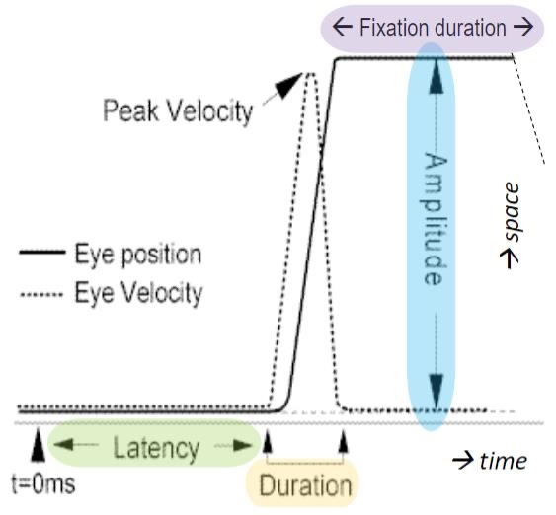

# **5 – Memory & Decision-making**

**Memory** is any way in which a past experience affects future thoughts or behaviors

We still conceptualize various stages of memory: Sensory, STM/WM, LTM

Sensation ≈ **sensory memory**, because neural activity caused by a sensation isn’t turned off like a light switch

Activity in early regions decays over time.

Our senses register a lot of information (e.g. the whole visual field), but only part of it is consciously processed, A.K.A. only part of it enters STM (= attentional orienting!)

The learned relationships among objects are a matter of long-term memory ... yet, this knowledge does aid STM → interdependence

Interaction between top-down & bottom-up (perception lecture) works for memory too!

STM: what’s the limit?

Instead of framing the limit in terms of number of objects, frame it in terms of **amount of information**.

**Working Memory**: How does it work in the brain?

Sensory memory is easy: residual activity in early perceptual regions of the brain

**PFC** (Prefrontal Cortex) is key... but so are all our perceptual areas

We can ‘read minds’ by looking at the visual cortex looking memorizing

So, memories are ‘stored’ - or at least read out in the visual cortex too

‘Higher’ regions like the PFC coordinate activation in perceptual regions during retention

**LTM** is the seemingly infinite archive into which we have stored every experience since our existence

- Though the archive is infinite, stored files may ‘wither’

- Throughout our lives, we are automatically building the archive - for strategic purposes

learning, automatization, bolstering WM

primacy effect (first word advantage): first words get full attention; STM not occupied by other things, and/or words were rehearsed for a longer amount of time

recency effect (last word advantage): Last words are still in STM

What’s the difference between **semantic and episodic memory**

Past experiences vs. facts

**Decision-making** is the bridge between perception (+memory, emotions, biases, predispositions, etc. etc. etc.) and action

**Expected utility theory**: Given knowledge about what the outcomes of various options will be, people choose whatever yields maximum value

**Confirmation biases**: We give more weight to information that confirms our expectations

**Overconfidence biases**: We trust ourselves more than others

**Prospect theory**: “people act on predicted emotions”

The drift diffusion model: Two competing neuronal clusters, evidence accumulates until one cluster (representing one decision) reaches threshold until then: doubt

Neural evidence: in Rhesus monkeys, direction-selective neuronal clusters are activated until one cluster’s spike rate hits threshold

# **6 – LMMs**

Fixed effects vs Random effects

FE: Experimental variable(conditions)

Those things about which we have hypothesis; (a specific direction of effect)

Covariates for which we expect a particular pattern

RE: subjects, items(stimuli)

Those things that we expect may be variable, but for which we do not expect a particular pattern.

Both in terms of intercept and slope, i.e. overall performance and effect strength

# **7 – Language & Reading**

Language vs. communication

**Communication**: any transmittance of any signal in any perceptual modality

Communication is the overarching thing; language is but a means to communicate

**Language** is a hierarchical system

Comprises building blocks that can be combined into building blocks that can be combined into building blocks…

Comprises rules about how to combine building blocks at each level of the hierarchy…

The set of structures that can be built following the rules is infinite

Letters are flexibly encoded for their positions.

Potential solutions:

- Positional noise: letters activate not only their slot but also surrounding slots

- Bigram representations: an intermediate layer between letters and words, where (location-invariant) letter combinations are activated

A new theory of orthographic processing...

PONG (the Positional Ordering of N-Grams)

-The brain is a sequence learner

-The brain estimates the laterality of N-grams through bi-hemispheric activation differences

We’re multiple words in parallel

Our expectations constrain the mapping of words onto locations

# **8 – Interfaces**

All man-made environments are interfaces

- Design determines how well its users can achieve their goals and tasks

- Environments are interfaces because they provide information that guide user decisions

Perception

1) Reduce signal-to-noise ratio

contrast, size, illumination, etc. (SDT!)

2) Don’t refer to more than 5 things with a single sensory dimension

3) Take top-down processing into account

4) Redundancy gain: convey information in multiple ways

5) Make things discriminable

Expectation

6) Realism: display elements should correspond to the real world

7) Realism – moving edition

Attention

8) Minimize access cost (i.e., navigating from one important location to another shouldn’t take effort)

9) Proximity compatibility

10) Divide processing load among the senses

Memory

11) Balance memory and perception: we do not have to memorize what we can see, and vice versa

12) Aid predictions (same as principle 11)

13) Safeguard consistency